H.T No
Regulations:
A17

Sreenidhi Institute of Science and Technology
(An Autonomous Institution)
Code No: 6F302 Date:13-Feb-2024 (FN)

B.Tech II-Year I- Semester External Examination, Jan/Feb - 2024 (Supplementary)
Mathematical Foundations of Computer Science (CSE & IT)

Time: 3 Hours Max.Marks:75

Note: a) No additional answer sheets will be provided.
b) All sub-parts of a question must be answered at one place only, otherwise it will not be valued.
c) Missing data can be assumed suitably.

Bloom's Cognitive Levels of Learning (BCLL)

Remember | L1 | Apply | L3 | Evaluate | L5
Understand | L2 | Analyze | L4 | Create | L6

Part - A Max.Marks:25
Answer all QUESTIONS

 |  | BCLL | CO(s) | Marks
1 | Define well formed formula. Is the expression (~P->Q -> R) a well formed formula? | L5 | CO1 | [2M]
2 | Determine whether the sequence 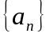 is a solution of the Recurrence Relation 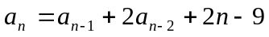, if 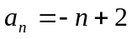. | L5 | CO2 | [2M]
3 | Write the properties of Lattice. | L2 | CO3 | [2M]
4 | Define Cosets and Homomorphism of groups. | L1 | CO4 | [2M]
5 | Define multigraph. Give an example | L1 | CO5 | [2M]
6 | Define Planar graph with an example. | L1 | CO6 | [3M]
7 | Define disjunctive syllogism and Modus Ponens. | L1 | CO1 | [3M]
8 | Define Compatability relation with an example. | L1 | CO3 | [3M]
9 | State the Lagrange’s Theorem. | L1 | CO6 | [3M]
10 | Define Semigroup with an example. | L1 | CO2 | [3M]
Part – B Max.Marks:50
ANSWER ANY FIVE QUESTIONS. EACH QUESTION CARRIES 10 MARKS.

 |  |  | BCLL | CO(s) | Marks
11. | a) | Using Truth Tables, show that ∼(P → Q ) → (∼Q) is a tautology. | L4 | CO1 | [5M]
 | b) | Obtain the Principal Disjunctive normal form for the  Expression (P ↔ Q) ∧ (∼P → R) | L4 | CO1 | [5M]
12. | a) | Verify the validity of the following argument: “All men are mortal. Socrates is a man. Therefore, Socrates is mortal.” | L3 | CO2 | [5M]
 | b) | Solve the Recurrence Relation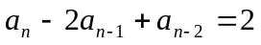. | L4 | CO2 | [5M]
13. | a) | Construct a relation Matrix for the following graph.  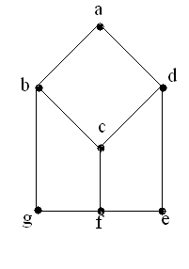 | L3 | CO3 | [5M]
 | b) | A relation R is defined over set of all integers as aR b⇔ b=ar for some positive integers. Show that the relation R is a partial ordering relation. | L2 | CO3 | [5M]
14. | a) | Explain about Monoid and Submonoid with giving an example each. | L2 | CO4 | [5M]
 | b) | State and prove Lagrange’s theorem. | L1 | CO4 | [5M]
15. | a) | Prove that the given two graphs are isomorphic graphs.  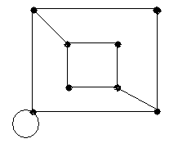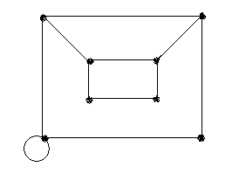 | L3 | CO5 | [5M]
 | b) | Define Depth first search and Breadth first search and a spanning tree. Explain through example. | L5 | CO5 | [5M]
16. | a) | Find the Euler path to the following graph.  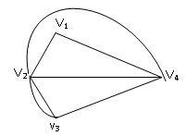 | L5 | CO6 | [5M]
 | b) | Find the Chromatic number for the following graph.  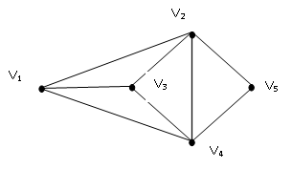 | L5 | CO6 | [5M]
17. | a) | Write antecedent and consequent rules of Automata Theorem Proving. | L2 | CO1 | [3M]
 | b) | Define particular Solution of recurrence relation. | L3 | CO2 | [4M]
 | c) | Let X={2,3,6,12,24,36}. Draw the Hasse diagram for the POSet [ X ; ]. (Note:| Stand for division) | L3 | CO3 | [3M]
18. | a) | Explain about Algebraic system with an example. | L2 | CO4 | [4M]
 | b) | Discuss about Bipartite and Complete Bipartite Graphs. | L3 | CO5 | [3M]
 | c) | Draw the following.  i) A graph which is Both Hamiltonian and Eulerian.  ii) A graph which is Hamiltonian but not Eulerian. | L2 | CO6 | [3M]
-- 00 -- 00 –

